***Towns and places***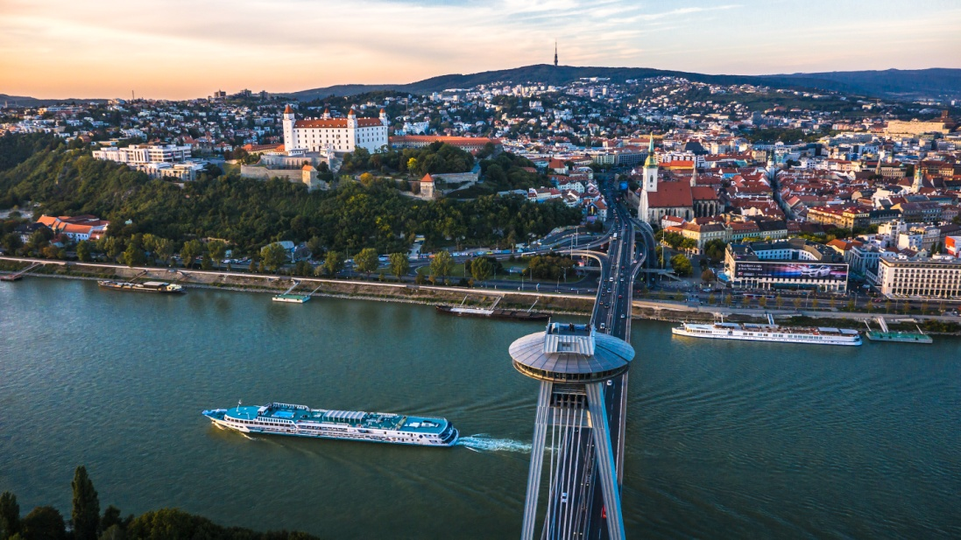

* capital city of Slovakia – Bratislava
* big city
* many beautiful buildings like UFO restaurant, SNP bridge …
* Bratislava castle
* Dunaj – river, ships
* Devín castle

***TOWNS AND PLACES***

***Reasons for moving.***

People have many reasons for moving.

There are for example: work, school/education, fun, hobbies,holiday, shoping, new partner ...

***Important places in my life.***

birthplace: Gelnica

native town : (Village) Prakovce

study places: Prakovce and Gelnica (some information about study)

weekend and holiday places: Maria Huta, Gelnica,Košice(cinema)

***Definitions:***

TOWN: a built-up area with a name, defined boundaries, and local government, that is larger than a village and generally smaller than a city.

VILLAGE: a group of houses and associated buildings, larger than a hamlet and smaller than a town, situated in a rural area.

CITY: a large town.

***COMPARE TOWN-VILLAGE***

***Famous places***

## Amazon forests (beautiful but dangerous), Machu Picchu(exotik), Paris and London (historical places),....

## *My trip to Roma*

....................................................

***Place in my dreams ( relax)***

My dream place for relax is situated in small village in mountains. Around this place is very good nature and much animals. Birts on trees sing every day some new songs but when they no sing in my kingdom is completely silence and that's the right thing for my relax.

***Places I have visited in my life***

Paris, Roma, USA, Rusia, Australia, Afrika, Antarktída, Island